Premium Indian Cumin Seeds – The Soul of Global Cuisine
Meta Description: Discover premium whole cumin seeds (Jeera Beej) from The Export Express, India’s trusted exporter of aromatic spices. High flavor, pure quality, and global export standards.

🌿 Introduction: The Timeless Spice of India
Few spices hold as much cultural, culinary, and medicinal importance as Cumin (Cuminum cyminum). With its warm aroma and earthy flavor, cumin is one of the oldest known spices — used since ancient Egyptian and Indian civilizations for food, medicine, and ritual.
At The Export Express, we bring you Premium Whole Natural Cumin Seeds (Jeera Beej) — freshly harvested, sun-dried, and quality-tested to meet global export standards. Our cumin reflects India’s spice heritage, trusted by gourmet chefs, herbal product makers, and global distributors alike.

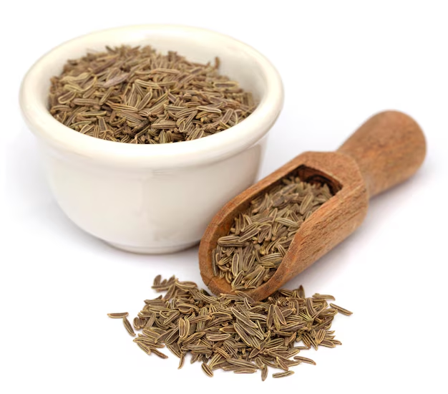
Caption: Premium Indian Cumin Seeds – earthy, aromatic, and 100% natural.

🧾 Product Specifications
Parameter | Specification
Product Name | Whole Cumin Seeds (Jeera Beej)
Material Type | Raw
Color | Brownish-Black
Packaging Type | Packet
Packaging Size | 500 g (custom sizes available)
Shelf Life | 12 Months
Origin | Made in India
Availability | In Stock
Certifications | FSSAI, ISO, Export Grade
Form | Whole Natural Seeds

🌱 Source and Authenticity
Our cumin seeds are sourced from the arid plains of Gujarat and Rajasthan, regions known for producing India’s most aromatic and oil-rich cumin.
Each batch is carefully cleaned, sieved, and hand-sorted to ensure uniformity and purity. At The Export Express, we maintain high export-grade standards by controlling moisture levels, color consistency, and aroma preservation through traditional drying techniques.

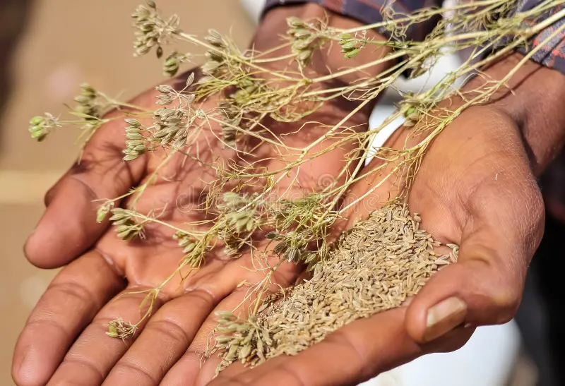
Caption: Cumin cultivation in India – traditional farming meets modern export quality.

💚 Flavor Profile and Aroma
- Taste: Earthy, nutty, slightly spicy, with a warm undertone.
- Aroma: Strong, penetrating, and slightly citrusy with hints of lemon.
- Texture: Firm, dry seeds with uniform color and size.
Whole cumin is toasted lightly to unlock its essential oils, creating a rich and smoky flavor that enhances cuisines worldwide.

🍴 Culinary Uses: From Indian Kitchens to Global Recipes

1. In Indian Cuisine
Cumin (Jeera) is indispensable in Indian cooking — it’s used in tempering (tadka), spice blends, and curries.
- Jeera Rice
- Dal Tadka
- Paneer Butter Masala
- Chaat Masala
- Rasam and Sambar

2. Global Culinary Presence
Cumin travels across borders:
- Mexico: Key spice in chili and tacos.
- Middle East: Enhances falafel, kebabs, and pilafs.
- Europe: Used in bread, soups, and cheese flavoring.

3. In Spice Blends
Cumin is an essential component in:
- Curry Powder
- Garam Masala
- Berbere (Ethiopian blend)
- Taco Seasoning

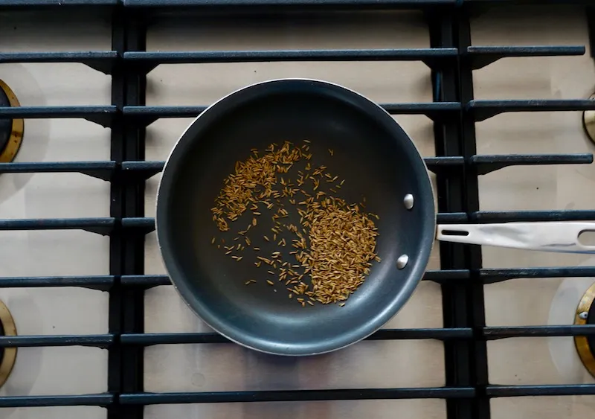
Caption: Toasted cumin releases deep nutty aroma – the secret to authentic flavor.

🌿 Health Benefits of Cumin Seeds
According to Ayurveda and modern research, cumin supports multiple systems in the body:

1. Improves Digestion
Cumin stimulates the production of digestive enzymes and bile, promoting better digestion and relieving bloating.

2. Rich Source of Iron
One teaspoon of cumin provides over 20% of daily iron needs, vital for energy and metabolism.

3. Powerful Antioxidant
Loaded with polyphenols that reduce oxidative stress and strengthen immunity.

4. Regulates Blood Sugar
Studies suggest cumin aids insulin sensitivity and may help balance blood sugar levels.

5. Boosts Immunity
With antimicrobial and anti-inflammatory properties, cumin supports overall defense mechanisms.

6. Traditional Remedies
- Chewing raw cumin for acidity relief.
- Cumin water (Jeera Pani) for detoxification.
- Steam inhalation with cumin for colds and congestion.

🧘‍♀️ Cumin in Ayurveda
In Ayurveda, cumin is called Jeeraka, meaning “that which helps digestion.”
It is considered:
- Tridoshic, balancing all three doshas when used moderately.
- Helpful for Agni (digestive fire) and detoxification.
- Used in classical formulations like Jeerakarishta and Trikatu Churna.
Cumin water, mixed with coriander and fennel, is a traditional Ayurvedic blend for cleansing and hydration.

📊 Nutritional Profile (per 100 g)
Nutrient | Value
Energy | 375 kcal
Protein | 18 g
Carbohydrates | 44 g
Fat | 22 g
Fiber | 11 g
Iron | 66 mg
Calcium | 931 mg
Magnesium | 366 mg

🏭 Why Choose The Export Express

✅ Premium Sourcing
Direct procurement from certified farms ensures consistent aroma and flavor profile.

✅ Quality Processing
Seeds are dried naturally, mechanically cleaned, and packed under hygienic conditions.

✅ Global Export Standards
FSSAI, ISO, and GMP certified; suitable for bulk, private label, or retail exports.

✅ Sustainable Practices
Eco-friendly packaging and fair-trade procurement model.

📦 Packaging & Export Options
Type | Size | Material | Use
Retail Packet | 500 g / 1 kg | Food-grade Pouch | Domestic / Online Sales
Bulk Bag | 25 kg | Jute / PP | Export
Vacuum Pack | 10 kg | Plastic Barrier Film | Aroma Preservation

🌍 Global Demand
Indian cumin accounts for over 70% of the world’s cumin export, with strong demand from USA, UAE, UK, Saudi Arabia, and Europe.
The Export Express caters to:
- Food processing industries
- Spice brands
- Health & nutrition companies
- Private label exporters

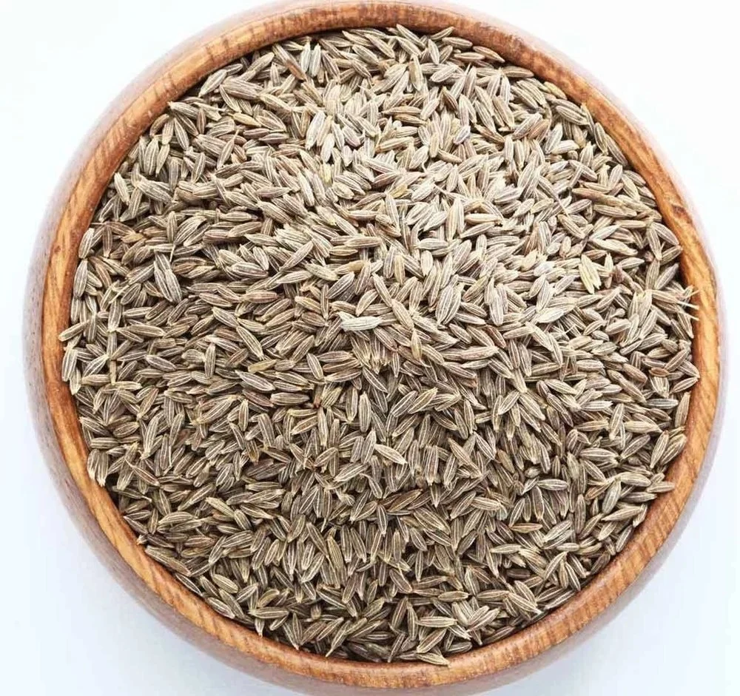
Caption: The Export Express – delivering purity, flavor, and reliability in every shipment.

From Indian kitchens to international markets, Cumin Seeds (Jeera Beej) are the soul of countless dishes and traditional remedies.
At The Export Express, we ensure every grain of cumin carries India’s rich aroma, authenticity, and unmatched flavor — perfectly packed for export and culinary excellence.
Whether for cooking, health, or trade — our Premium Whole Cumin Seeds deliver the purity and potency your customers deserve.

Keywords: cumin exporter India, herbal export India, cumin seeds export, whole cumin seeds, Jeera Beej exporter, The Export Express.

